Order ! VeryWonky
To:
CB Industries FAX Nr: +41 (0) 32 623 72 73
Felix Schaffner
Gewerbestrasse 13
4512 Bellach 29.07.2026

Order: Please enter quantity: *double click opens Exel Sheet

Underline sample or better: delete the one you do not want.

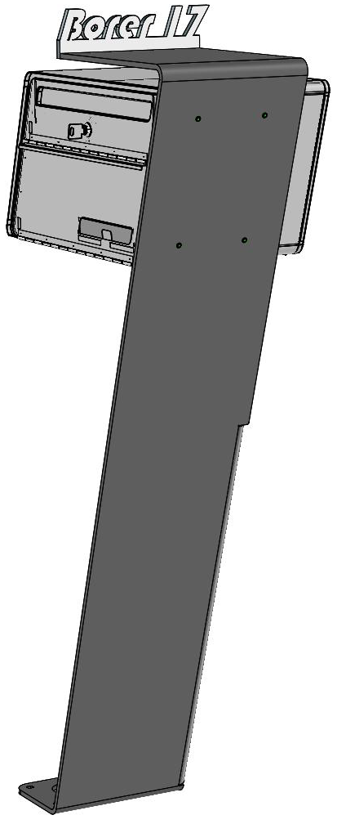
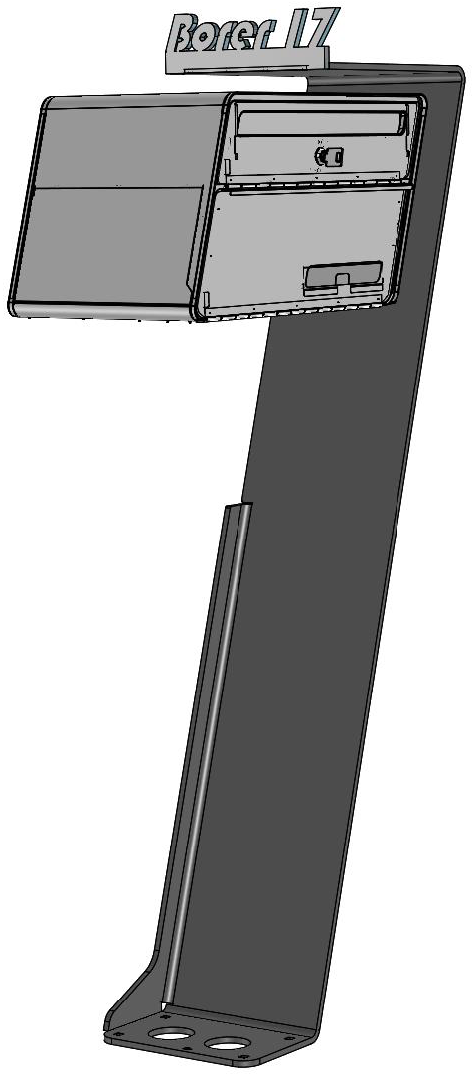
Your Name:
We need to know from which side your name needs to be readable.
From this side I want to read my name:

Name:
ס Lenght equal
ס Lenght overlong (more than 9 letters)

Overlong:
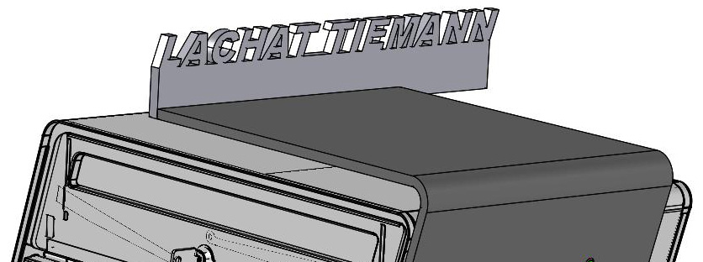

Block Letters:
Payment  - Check  - Payment in advance  Date: 29.07.2026  Sign:  Name to cut: | Name, Prename  Street:  Zip / Town:  Country:  Tel / Fax:  Email:
designmailbox.ch

